Lab - Troubleshoot uRPF

# Topology

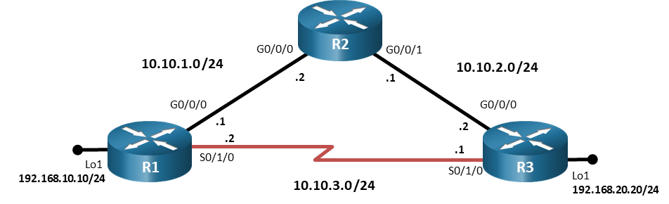

# Addressing Table

| Device | Interface | IP Address | | Subnet Mask |
| --- | --- | --- | --- | --- |
| R1 | G0/0/0 | 10.10.1.1 | | 255.255.255.0 |
| R1 | S0/1/0 | 10.10.3.2 | | 255.255.255.0 |
| R1 | Lo1 | 192.168.10.10 | | 255.255.255.0 |
| R2 | G0/0/0 | 10.10.1.2 | | 255.255.255.0 |
| R2 | G0/0/1 | 10.10.2.1 | | 255.255.255.0 |
| R3 | G0/0/0 | 10.10.2.2 | 255.255.255.0 | |
| R3 | S0/1/0 | 10.10.3.1 | 255.255.255.0 | |
| R3 | Lo1 | 192.168.20.20 | 255.255.255.0 | |

# Objectives

Troubleshoot issues related to the configuration and operation of uRPF.

# Background / Scenario

uRPF is a security feature that helps limit or even eliminate spoofed IP packets on a network. In this lab, you will be loading configurations with intentional errors onto the network. Your tasks are to FIND the error(s), document your findings and the command(s) or method(s) used to fix them, FIX the issue(s) presented here, and then test the network to ensure both of the following conditions are met:

* + - * 1. The trouble ticket has been resolved
        2. The network is fully functioning

**Note**: The routers used with CCNP hands-on labs are Cisco 4221 with Cisco IOS XE Release 16.9.4 (universalk9 image). Other routers and Cisco IOS versions can be used. Depending on the model and Cisco IOS version, the commands available and the output produced might vary from what is shown in the labs. Refer to the Router Interface Summary Table at the end of the lab for the correct interface identifiers.

**Note**: Make sure that the devices have been erased and have no startup configurations. If you are unsure, contact your instructor.

# Required Resources

* 3 Routers (Cisco 4221 with Cisco IOS XE Release 16.9.4 universal image or comparable)
* Console cables to configure the Cisco IOS devices via the console ports
* 1 PC (Choice of operating system with a terminal emulation program installed)
* Ethernet and serial cables as shown in the topology

# Instructions

* 1. **Trouble Ticket 22.1.3.1**

Scenario:

As a security measure, uRPF was implemented on router R1 to ensure a malicious actor could not circumvent access control restrictions using a spoofed IP address. A fellow colleague was tasked with configuring uRPF on R1 to ensure that any spoofed IP packets received are dropped. However, after the implementation, R3’s loopback address has lost connectivity to the 192.168.10.0/24 network.

### Cable the network as shown in the topology.

* + - 1. Attach the devices as shown in the topology diagram, and cable as necessary.
      2. Use the commands listed below to load the configuration files for this trouble ticket:

|  |  |
| --- | --- |
| **Device** | **Command** |
| R1 | **copy flash:/enarsi/22.1.3.1-r1-config.txt run** |
| R2 | **copy flash:/enarsi/22.1.3.1-r2-config.txt run** |
| R3 | **copy flash:/enarsi/22.1.3.1-r3-config.txt run** |

**Note**: Passwords on all devices are **cisco12345**.

### Troubleshoot Ticket.

Troubleshoot and repair the issue. All devices, including loopback addresses, should be able to ping each other.

### Complete the Ticket.

1. After you have fixed the ticket, change the MOTD on Router R1 using the following command:

**banner motd # This is $(*hostname*) FIXED from ticket <*ticket number*> #**

1. Verify that uRPF is enabled, configured correctly and all devices, including loopback addresses, can ping each other. Then save the configuration by issuing the **wri** command.
2. Inform your instructor that you are have completed the ticket.
3. After the instructor approves your solution for this ticket, issue the **reset.now** privileged EXEC command on each device. This script will clear your configurations and reload the devices.

# Router Interface Summary Table

| Router Model | Ethernet Interface #1 | Ethernet Interface #2 | Serial Interface #1 | Serial Interface #2 |
| --- | --- | --- | --- | --- |
| 1800 | Fast Ethernet 0/0 (F0/0) | Fast Ethernet 0/1 (F0/1) | Serial 0/0/0 (S0/0/0) | Serial 0/0/1 (S0/0/1) |
| 1900 | Gigabit Ethernet 0/0 (G0/0) | Gigabit Ethernet 0/1 (G0/1) | Serial 0/0/0 (S0/0/0) | Serial 0/0/1 (S0/0/1) |
| 2801 | Fast Ethernet 0/0 (F0/0) | Fast Ethernet 0/1 (F0/1) | Serial 0/1/0 (S0/1/0) | Serial 0/1/1 (S0/1/1) |
| 2811 | Fast Ethernet 0/0 (F0/0) | Fast Ethernet 0/1 (F0/1) | Serial 0/0/0 (S0/0/0) | Serial 0/0/1 (S0/0/1) |
| 2900 | Gigabit Ethernet 0/0 (G0/0) | Gigabit Ethernet 0/1 (G0/1) | Serial 0/0/0 (S0/0/0) | Serial 0/0/1 (S0/0/1) |
| 4221 | Gigabit Ethernet 0/0/0 (G0/0/0) | Gigabit Ethernet 0/0/1 (G0/0/1) | Serial 0/1/0 (S0/1/0) | Serial 0/1/1 (S0/1/1) |
| 4300 | Gigabit Ethernet 0/0/0 (G0/0/0) | Gigabit Ethernet 0/0/1 (G0/0/1) | Serial 0/1/0 (S0/1/0) | Serial 0/1/1 (S0/1/1) |

**Note**: To find out how the router is configured, look at the interfaces to identify the type of router and how many interfaces the router has. There is no way to effectively list all the combinations of configurations for each router class. This table includes identifiers for the possible combinations of Ethernet and Serial interfaces in the device. The table does not include any other type of interface, even though a specific router may contain one. An example of this might be an ISDN BRI interface. The string in parenthesis is the legal abbreviation that can be used in Cisco IOS commands to represent the interface.

End of document